LOGO /College Name
/ V
IDYUTH – Power of EEE /
Vol 2 : Issue 2 Jan 2020

Dear Staff and Students ,

A warm welcome , once again to the YEAR of DESTINY 2020 , as was named by Late Sri APJ ABDUL KALAM , The Peoples President of India. By 2020 , it was the dream of APJ Sir , to see INDIA as a SUPER POWER , one among the equals , amidst USA , Russia , CHINA ,JAPAN , UK , France .

It is our country’s singular misfortune that we lost such a noble and gentle person from our midst.
All members of EEE, stand united in our heartfelt prayers, to remember Sri APJ Sir till the GOAL of INDIA – A SUPER POWER is achieved.

Let us all PLEDGE to “Arise, Awake and STOP NOT till the GOAL is reached!! “

उत्तिष्ठत जाग्रत प्राप्य वरान्निबोधत।
क्षुरस्य धारा निशिता दुरत्यया दुर्गं पथस्तत्कवयो वदन्ति ॥

Arise, awake, find out the great ones and learn of them; for sharp as a razor's edge, hard to traverse, difficult of going, is that path, elucidate the learned sages.

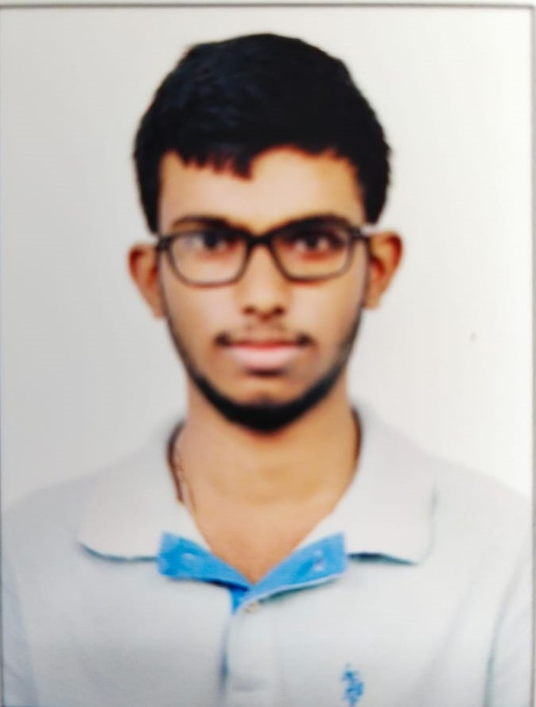 N.VIJAYAKAR 160718734003 EEE

Consciousness “is that which abandons us in the evening as we sleep and reappears the next morning when we wake up” (Edelman 2000; 1).

Even after so many centuries we don’t know what the exact definition of consciousness is. Most people say we do things consciously but may psychologists have proven that every time we do an action, it might be the because of our sub-consciousness. This is mostly because we don’t know the exact difference between consciousness and sub-consciousness.
Sub-consciousness is something which we have been programmed with, since our birth, more like a reflex action. Most of our daily actions are done through our sub-consciousness. As an example, I am writing this article which is a conscious process in which I am directing my brain to do this specific action. However, while writing I am breathing, no specific direction is to be given to the brain to do that!! It happens “Naturally”!

In my opinion feelings are also a conscious process when we feel that we love someone we consciously cognize that love towards that person, we don’t feel like that towards a person as long as we don’t consciously think about it, at the start we only get attracted to that person then we think about it and then we love that person, so this implies that our conscious thoughts are our feelings.

This is not same when it’s about our families, we are programmed to love them from our birth so we just do it through our sub-consciousness.

SELF CONFIDENCE

Self-confidence is a combination of a state of mind and a strong feeling of self-belief. This is commonly used term, when one needs self-assurance especially in one's personal judgment, power, ability etc. It is that voice which comes from your inside and gives you a boost to do something which you fear. In today's epoch, there is no place for one who lacks self-confidence because of stiff competition all around. Many number of people possess it and, a great many people are achieving their goals using confidence as a ladder.

For students, confidence plays a key aspect of their study life. Higher the self-confidence, greater the chances of success. Anyone who has inculcated this ability enjoys various perks. One of them is that the magnitude of the difficulty of a tough job decreases. It keeps you going when you face failure in your life. It helps you to focus on the areas which held you down. It gives a spark to your mind to improve and excel in the next try.

If you are deficient in this much-needed ability then, there are chances that you would be dominated by pessimism. The absence of confidence can be the reason for your sorrow and dissatisfaction. Simple chores of daily life seem to be challenging when you lack confidence. Self-confidence is the pre-requisite to success and happiness. For many, it would be a challenging thing to be confident all the time. Excess of everything is bad. Surplus amount of confidence is also not beneficial. Over-confidence has become the reason behind the failure of many. People who are experiencing it overlook the other side of the coin and tend to embrace themselves every now and then which at some point in time proves harmful. Hence, they end up with defeat. Combination of the three P’ Passion, Patience and Perseverance is just magical. You can vanish all your stress and anxiety by learning and practicing the power poses. Practicing a power pose is an instant solution to this. When you practice the poses, your mind releases such hormones which uplift the level of self-assurance.
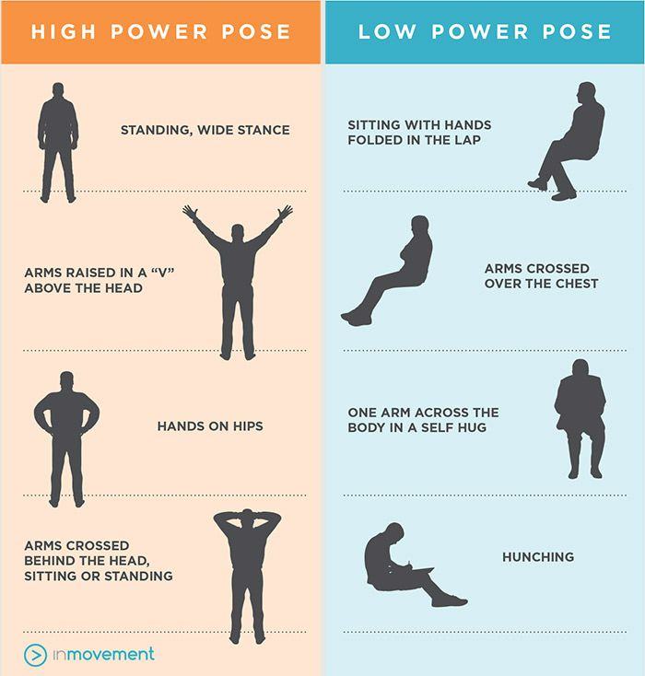
A session on “power poses” in a classroom, practicing power poses can actually do well to your mind.

B.Akhila Reddy 160718734002 EEE

)(()()()()()()()()()()()()()()()()()()()()()()()()()()()()()())()())()()()()()()()()()()()()()(()()()()(()()()(()(()()()()()()()()()))
Our department has seen many  batches graduating from its portals and has  very good Nostalgic memories of  1) Varun Kumar , Trinath Reddy ,  Ranjitha, Harish Goutham , Ramya ,  Keerthi G , Md Raza , Saad Mirza and  others of the 1 st Batch ( 2008 – 2012 )  2) Sachin Dharmini ( The FIRST GOLD  Medalist of the COLLEGE ),  Charitarth , Veronica , Ram singh ,  Meenakshi Sharma , Nagaveena ,  And others of 2nd Batch (2009- 2013 )  3) Roja kiranmayi , Shanthi Priya ,  Zohair Qureshi , Siliveri Jyotsna ,  Chiluka rahul and others of 3rd Batch ( 2010-  2014 )  4) Chada anvesh , Palnati sandeep ,  Deekshitha , Manasa, Sridevi, Owais  Bukhari , Vicky Sharma and many  others of 4th Batch (2011 – 2015)  5) Tejeshwar Rao , Varun raj , Akhila ,  Nagatejaswini , Neerrati Suresh ,  Anjum Sultana , Azaruddin and  others of 5th Batch ( 2012-2016)  6) Chiluka Pragna , Shiney priyanka ,  Tayyaba , Nandini, Rajasekhar and  others of 6th Batch (2013 – 2017) | 7) Pankaj Kamle , Meher Krishna ,  Dorothy , Sai suraj , Basha ,  Waheedunnisa, Maliha , Manasa  Chintala , Jashuva , Prashanthi ,  Shravya and others of7th Batch ( 2014-2018)  8) Jachin , Chandrahas , Harish , ……of 8th Batch (2015 – 2019)  9) Sainath , Sai Pavan , Akhilesh , Amisha , Roshini, Sravya , Swathi, Maqbul ,Srinidhi , Harshitha and many others of 9th Batch (2016 – 2020)  10) 2017-2021 batch is the 10th BATCH with Ramini Sowmya , Mounica , Pavani , Sai , Akhil , Zubair , Farhan , Amareshwari , Radhakrishna and many others .  LET US CELEBRATE the 10 BATCHES of EEE GRADUATES from MCET

COLLECTING FULL SOLAR ENERGY

Human race begin a long time ago and human mind get advanced and inventing new technology, using earth natural resource and built nuclear reactors collecting energy from solar light, discovering science fundamentals and understanding quantum level physics and exploring universe its great but are we really advanced civilization

In 1964 soviet astronomer Nikolai kardashev introduced a scale which is said to be NIK HYPOTHETICAL SCALE, it categorized civilization into 3 types This scale depends on an algorithm by calculating how much a civilization energy, here there are:

1. TYPE-1 civilization
2. TYPE-2 civilization
3. TYPE-3 civilization
The time difference between these 3 level would be vast

Every day we get a huge amount of solar energy from our sun, but we are using only 1% of its total energy.

TYPE-1: this civilization can grab full solar power which fall into their own planet but present our civilization were not capable of grabbing full energy of sunlight which falling into our planet earth

SO WHAT WE ACTUALLY ARE:

Karl Sagen invented a formula that can say which type of civilization it is K = LOG1oP-6/10
Where k = hypothetical civilization rating P = energy using by a planet
Type-1 civilization uses a minimum of 10^6 energy but we used 17.35 billion watts of energy only, so our civilization rating is 0.72.

Theoretical physicist Nikio cok said in the next 100 years our 0.72 civilization will be grown to type-1 civilization which will become one the biggest achievement in human history Because technology aspects our civilization moving exponentially which means growing at double speed.
What special with Type-1: if we were type-1 civilization we can control and colonize entire solar system, can observe full energy of solar light which fall into our planet,we can modify and control their own planet as we required ,we can also modify weather in our planet and many things we never imagined that we can do.
But still we are not a very advanced civilization, because our civilization technology was limited to our planet, we cannot control our planetary system and cannot observe full energy from the sun, it takes several thousand years to become a type-2 civilization from type-1 civilization.

TYPE-2 CIVILIZATION:
This civilization is more advanced civilization compared to type-1 civilization,type-2 can not only control their own planet but also other planets in its solar system, they can colonize to other planets and change position of that planets they can do mining on asteroids to get resources ,present our world population is 700 cores after becoming type-2 civilization population become much more and the demand of energy will get increased ,for that purpose type-2 civilization grab full energy from their star by DYSON SPHERE. This theory was proposed by FREEMAN DYSON in 1960.

Dyson sphere

DYSON SPHERE: it is MEGA structure built around sun to observe its energy maximum, this energy would be enough for entire type-2 civilization, using such energy we can build other mega structures in space and travel to long distances in space and make

colonies in other planets and make them habitable to live, there are many complication a head to build Dyson sphere,the first thing is design, material, transport, energy. the design around the sun shouldbe a Dyson swarm which means an enormous set of orbiting panels that collect the sun’s power and send it ,such a swarm would give humanity basically unlimited energy.
but building it won’t be easy, sun is so big enormous satellites were required, if each satellite is a square kilometer we need around 30 quadrillion to surround sun, but even if they built as lightly as possible we need about 100 quintillion tons of material and then energy to actually put the parts together and deliver them to their positions around sun and top of that we need a permanent infrastructure set up in space to start building.
How can it all be DONE….!

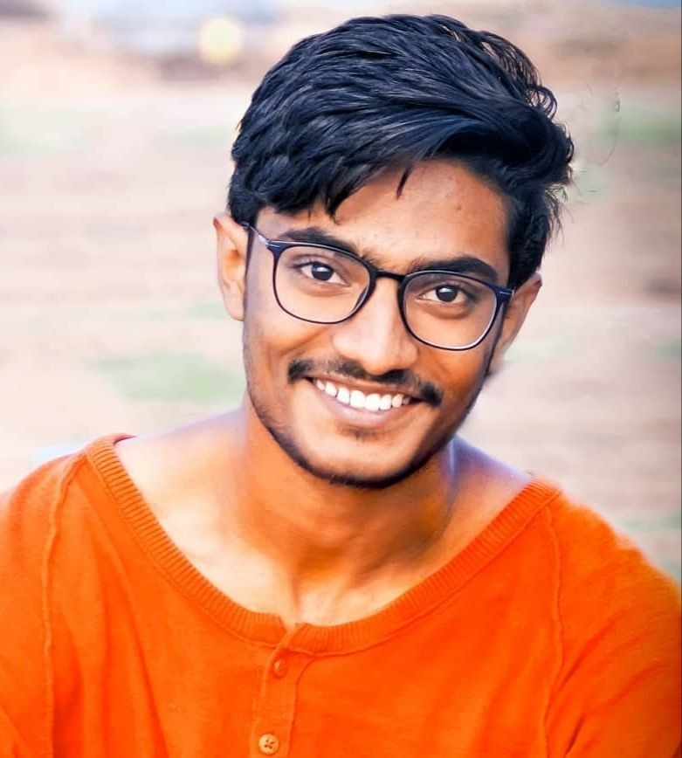 Ch.Pavan Kumar V SEM

This is a poem written by Mr Sriilalit Narayana, on the spur of the moment in 2013 Jan/Feb during your senior batch GATE Exam... trust the same would be motivating to you all even now!!

To all those attempting GATE 2021 /2022 Wishing You all the very best!!

Attempting “GATE” is Tempting “Fate”
You don’t expect the doors of GATE to be open!
A small leeway between them, brings a chance Golden!!

Slogging by day and burning oil, by midnight
would make you weary for the BIG FIGHT

So relax for a while, show your face in college!!
Collect all the best wishes in person and in a big package!

Add a method in madness!!
Drive away sadness
come to college ,
See the green foliage!

Oh!! Yeah!! Attempting GATE is TEMPTING FATE
drive away your self-doubt , resolve to never miss the bus
Who knows! You will discover a new wonderland and be a new Columbus!!

So get up and be ready to win a place in the forefront of the race
and let newspapers / TVs flash your pretty/ handsome face

Oh! Yeah! attempting GATE is your “ Baye Haat ka Khel “;
Jab ho tumhare haat , speed and accuracy “ kaa taal mel”

Attempting Gate is opening a FLOOD GATE
For many opportunities. Young MATE!!

so let not this slip bye
gather your wits and work smart ,
do not be shy.

Wish you all the very best.
sriilalit

Student Activities :

S. No | Event conducted | Class Participated | Resource /Technical Programme | Date
1. | One day symposium on Recent Trends in Electrical  Engineering | III , V and VII SEM  students | MCET/ Guest Lecture, Technical Quiz, Wealth From Waste Exhibition,Painting on  Energy Saving | SEP -06-  2019
 | 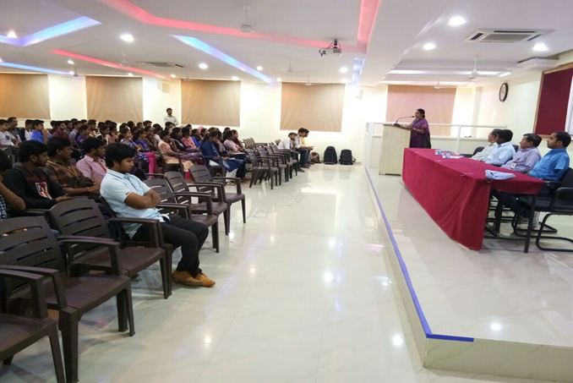
2. | Guest Lecture on Electricity Regulation and power  Procurement Process | III,V and VII sem | Mr. M.S.Vidyasagar, Deputy Director Planing &Power Procurement | 06-09-2019
 | 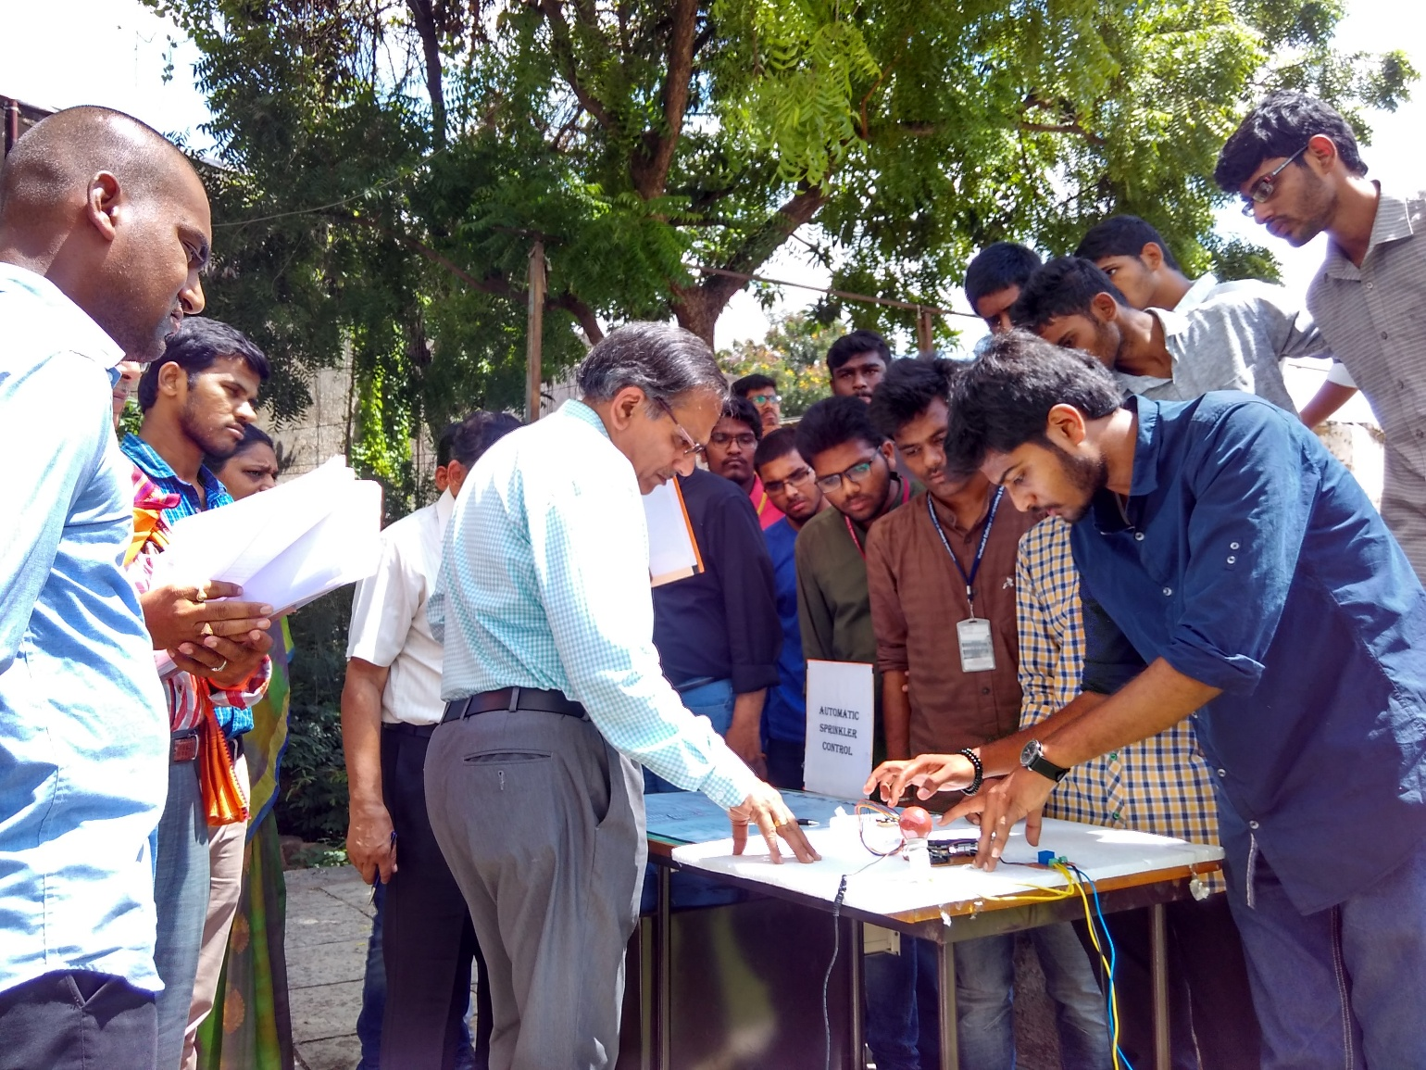
3. | Super Critical Steam Generator- FGD Concept | III,V and VII sem | Mrs.Sk.Yasmeen, ADE, Kothagudem Thermal Power  Station, Palvoncha | 06-09-2019
 | 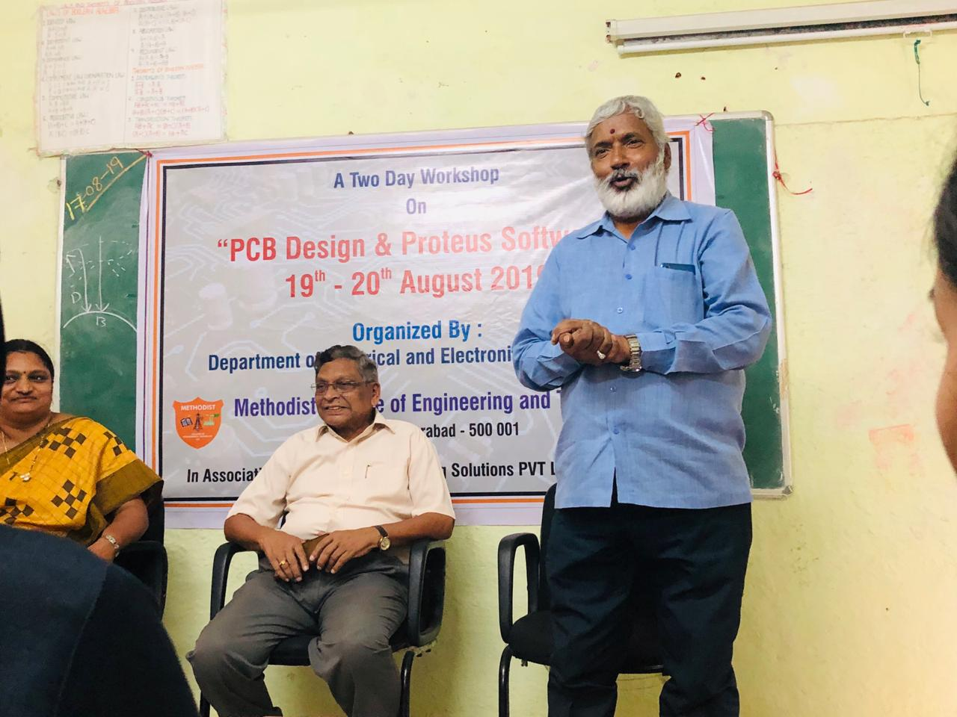

IMPACT OF SOCIAL MEDIA - CONSEQUENCES AND USES
ABDUL MATEEN
EEE-160719734311

Impact of social media on day to day life
As we all familiar with social media platforms that cause huge impact on our daily life positively and negatively. Mostly the youth of our generation are most active and energetic in this platforms. Various platforms like (Facebook, twitter, what’s app ,etc.)
From the past two decades social media has got fame Worldwide. Now, almost everyone from our society is connected with this platform most of among them are our youth. As they spend lot of their time despite of being useful or not. The positive side of this platform is updates of what is happening around, we can connect with our fellows despite of long distance and stay connected with them as long as possible. It reduces the physical meeting which is more helpful during this pandemic. With use of this you can also share the data (files, images, relevant documents) with in a fraction of seconds. Now a days you can show case your talent on social media networking sides which gives you an encouragement from the people. Many of the institution opt this platform for the conduction of classes through which learners can be able to study repeatedly and efficiently.
Although, it has negative impacts too, being online for long hours made more strain on eyes and leads to many causes. Most of the people get addicted towards this platform which simple causes anxiety, depression and disturb psychological mind. There are so many trolls &amp; hackers you might face while usage of this networking sides which can fetch your personal data and any privacies of yours.

GRAPHENE SUPER CAPACITORS- THE FUTURE OF BATTERY POWER
by
Shaik Zubair,
160717734021,
EEE.

From laptops that charge in 15 minutes to electric scooters, the first round of graphene-based products could finally deliver on the promise of the much- hyped wonder material. Instead of holding electricity as chemical potential, like a battery, supercapacitors (also known as ultracapacitors) store it in an electrical field, like static collecting on a balloon. Because there’s no chemical reaction going on, they don’t degrade like lithium-ion batteries, which rely on rare-earth metals and can end up in landfill after two years. This means that you can charge them much more quickly – a five minute charge for one of Belgrade’s buses can carry it up to 18 kilometres. There are two reasons supercapacitors haven’t yet replaced batteries in our electric cars and electronics: they hold less energy in the same amount of space, and they can’t hold it for as long. A fully charged supercapacitor can leak down to empty in hours, rather than days. Discovered at the University of Manchester in 2004, graphene - which consists of thin flakes of carbon atoms arranged in a hexagonal structure - was quickly hailed as a wonder material. It is strong and light, with a high surface area, and it’s an excellent conductor of both heat and electricity. But, the promised graphene revolution is yet to materialise. It is much more environmentally friendly than lithium-ion overall, and can be much more easily recycled, the most common production processes for graphene still involve harsh chemicals, which may not be sustainable if it’s going to supply an electric car pool that could reach 125 million vehicles by 2030. But, if researchers can crack these problems – and they’re working on it – then graphene could fundamentally change the way our world is constructed. It could be used to make laptops with batteries built into the case, or electric cars that store energy in their doors or chassis instead of in bulky battery packs.

